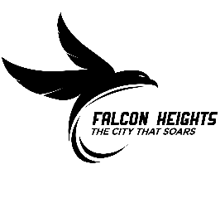
2025 Pavement Management Project

April 15, 2025

Project Summary
The 2025 Pavement Management Project in Falcon Heights is shown in the map below.
Falcon Woods
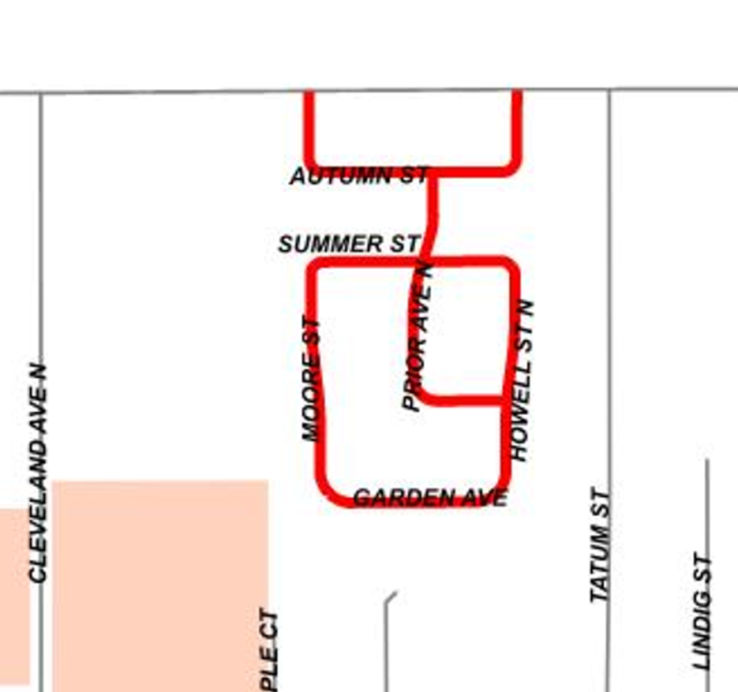
Northome
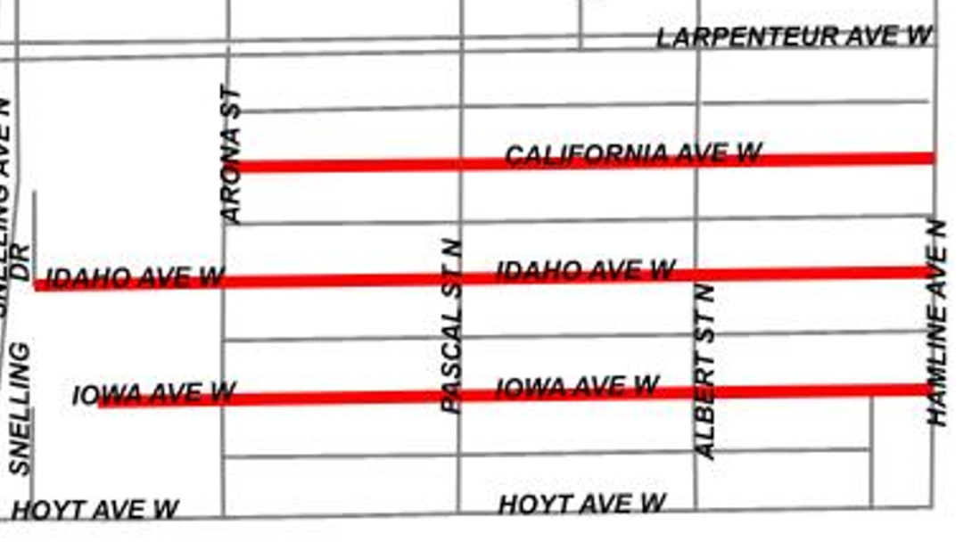
The proposed roadways in red will undergo a full depth reclamation, which would involve reclaiming (grinding) asphalt and mixing with the gravel below, and installing new pavement.
In the Falcon Woods neighborhood trails connecting the neighborhood to Community Park and to Prior Avenue will be rehabilitated. In the Northome neighborhood the Curtiss Field Park parking lot will be rehabilitated.
Spot curb repair and minor storm and sanitary repairs are also included.
Project Approval & Funding
The Council accepted the Feasibility Report on the project on December 11, 2024, and held a public hearing on January 22, 2024. On April 9, 2025, the Council awarded the 2025 PMP contract to Bituminous Roadways, Inc.
CONTACTS
Dan Turner, Sr. Project Coordinator
(651) 792-7045
Dan.Turner@cityofroseville.com
Erik Henricksen, City Engineer
(651) 792-7048
Erik.Henricksen@cityofroseville.com

Jack Linehan, City Administrator
(651) 792-7611
jack.linehan@falconheights.org

The cost to perform this pavement maintenance is funded by a combination of City funds, Municipal State Aid funds (Gas Tax) and Special Assessments. Utility repairs are funded using utility funds. A Special Assessment Hearing will be held this fall for Council to approve the finalized assessment roll.
Schedule
The contractor’s schedule is shown below. Please note, weather will be a factor and the schedule will likely change as the season progresses. We will send out additional newsletters as the contractor is moving to the next phase of their construction.
Week of April 28: Construction Start, Minor Utility Work and Curb Repair
Week of May 19: Begin Reclaiming (grinding) Pavement
Week of May 28: Begin Paving
Mid-June: Complete Paving
End-June: Anticipated Completion


We will send newsletters to update the schedule, but we recommend that residents check the City website for more frequent updates, hosted by the City of Roseville.
Use the QR Code to sign-up for weekly email updates once construction begins (“Falcon Heights Pavement Management”).
Construction Site Safety
We remind you to use caution around the work site. Your assistance in reminding children to stay clear of construction equipment is helpful in maintaining a safe environment. Your patience and cooperation during this construction is appreciated.
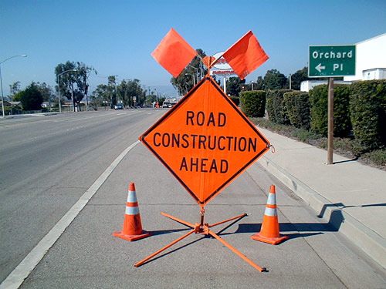
Please use extreme caution walking, biking or driving in and around construction areas. The large equipment may make it hard to see or hear you.
Access
The Contractor is required to keep the roads passable for residents and to provide driveway access whenever possible. Contractor will post temporary traffic control signage throughout the project. The construction project will be staged so that residents and emergency vehicles will be able to drive on the streets. If you have special access needs, please let us know.
If any street is temporary closed during utility work; residents will be able to detour around.
Private Systems in the Right of Way
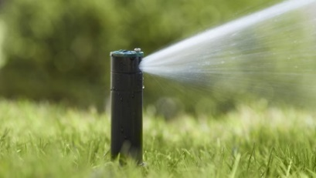
Curbs designated for repair will be marked ahead of the project. Private systems such as sprinklers, invisible fences, or landscaping near the curb repairs will be affected.
Please notify Dan Turner, Sr. Project Coordinator, immediately if you have an underground sprinkler system or an invisible fence in the boulevard. He will be able to determine if you need to move it out of the way before construction starts.
Necessary removal and repairs are the responsibility of the property owner.
Mail Delivery & Garbage Pick up
In the Falcon Woods neighborhood, the contractor may need to install temporary mail boxes during the project. You will be notified if temporary mailboxes need to be installed for your home. Schedules and times of mail delivery and garbage pickup should remain unchanged.
Survey Markers
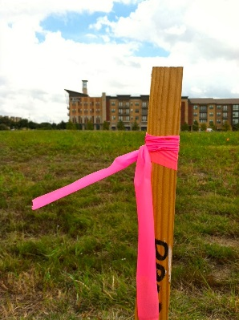
To perform the project construction, engineers place a series of survey markers for the contractor to measure from. Typically, these markers are offset several feet from the object or point they refer to so that they are not disturbed during the construction process. As a result, these offset markers are often placed well into a resident’s yard. Please notify Dan Turner, Sr. Project Coordinator, if any stakes have been moved accidently.
Contact Us!
If you have any questions, concerns, or comments please contact us at 651-792-7004 between 8 am and 4:30 pm.
Throughout the project, we will keep you informed through monthly direct mailings and weekly updates on the project website.
To receive notifications of website updates and other project related news, sign up for the Falcon Heights Pavement Management Project “Notify Me” List at cityofroseville.com/notifyme
After Hours
If an issue arises outside of regular business hours, contact the City’s 24-hour non-emergency number at 651-767-0640.

Utility Flags
To protect against underground utility damage, the contractor will be calling in utility locates through Gopher State One.
This is required by anyone digging a hole. Private and public utilities will locate their underground utilities by spray painting and placing flags in the boulevard.

